Observer or Citizen? The Asian American Way

By Carter Lee

February 17, 2023

[[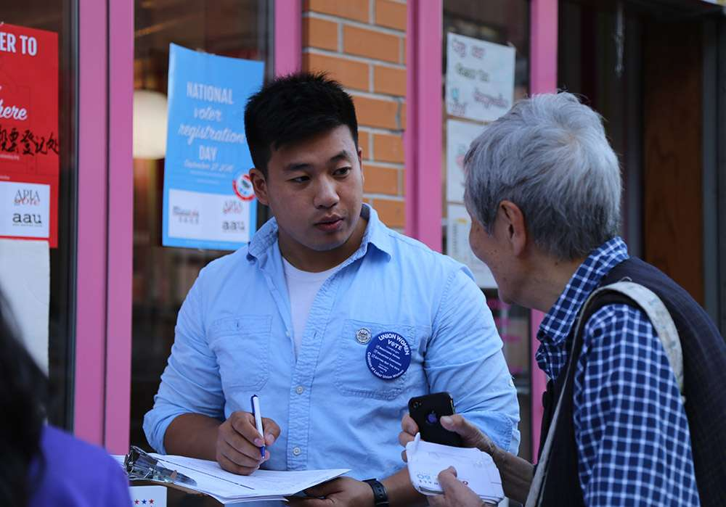](https://www.google.com/url?sa=i&url=https%3A%2F%2Fapiavote.org%2Fpolicy-and-research%2Fasian-american-voter-survey%2F&psig=AOvVaw1WIobd1NmaiLVttyQW0e7z&ust=1676752309854000&source=images&cd=vfe&ved=0CA8QjRxqFwoTCIC8n6Cznf0CFQAAAAAdAAAAABAE)1,000 × 699](https://www.google.com/url?sa=i&url=https%3A%2F%2Fapiavote.org%2Fpolicy-and-research%2Fasian-american-voter-survey%2F&psig=AOvVaw1WIobd1NmaiLVttyQW0e7z&ust=1676752309854000&source=images&cd=vfe&ved=0CA8QjRxqFwoTCIC8n6Cznf0CFQAAAAAdAAAAABAE)

Every day after elementary school, I went to my grandparent's house in Hayward, California and walked in to see the same familiar scene. My grandfather (爺爺 or Yeye in Chinese) staring at his computer and reading the news. He was a voracious reader and was always up to date on medical advancements, semiconductors, information technology, and world events. He always seemed aware of what was going on in America; however, since becoming an American Citizen in the late 1970’s, he and my grandmother have never voted in a US election. This lack of civic engagement is not only common to my family but to other Asian Americans in the US. Asian Americans are one of the fastest-growing racial or ethnic groups in the United States. However, they consistently have one of the lowest voter turnouts of any racial or ethnic group. This lack of civic engagement is concerning, especially as our country continues to grapple with issues of discrimination and inequality.

Asian Americans face significant barriers to political participation, like language barriers, complex voting processes, and a disconnect from mainstream American political culture all contribute to a lack of motivation to participate. When talking to my BYU Cantonese Professor about Asian American voter turnout, she mentioned that a lot of the older generation Asian Americans do not trust the political candidates and feel disconnected from America.

Many Asian Americans do not truly assimilate into American culture leaving some Asian Americans to feel out of place. According to “The Transnational Politics Of Asian Americans” by Christian Collet and Pei-Te Lien, in a survey interviewing first-generation Asians on “Which country do you consider your real homeland?” found that 47% percent replied that America is their homeland and 10 % chose not to answer. The uneasiness of the survey can point toward the fact that some amount of Asian Americans do feel xenophobia instead of xenophilia. The large disconnect between Asian Americans and politics paired with the lack of enthusiasm to vote influences the lack of Asian American participation in politics.

This disconnect is only fueled by the discrimination of Asian Americans in modern America. My Chinese friend once went to the BYU Harold B. Lee library to study when he was approached by an older individual asking him to go back to China and racial profiling him. Sadly this story is all too familiar to Asian Americans across America, I remember a time when I was in Colorado serving as a church missionary for the Church Of Jesus Christ Of Latter-Day Saints. This was during 2020 at the peak of Covid 19 and Asian hate crimes were on a rise. I would get random comments like “Go back to your country, you don’t belong here”. This discrimination and racism creates a sense of alienation and disconnection from American society. This discrimination and racism leads to racial profiling and stereotyping that can alienate Asian Americans and further discourage voter engagement.

The stereotype that all Asian Americans are apolitical and uninterested in the political process is untrue. These stereotypes are damaging to younger generations of Asian Americans. However, we have witnessed the work of faithful Asian Americans in Congress through Daniel Inouye, Patsy Minks, Mazie Hirono, and Kamala Harris. Patsy Minks was the first woman of Color and Asian American woman to be elected to Congress. She is best known for her work in the Title 9 Amendment of the Higher Education Act, which prohibits sexism or any discrimination in any education program or activity receiving federal financial assistance. Asian Americans have been instrumental in the development of our nation. Asian Americans’ diverse backgrounds bring a unique perspective to our government that needs to be seen and heard. There have been many instances when Asian Americans have been politically active in America and across the world which can be seen in Tiananmen Square when the Chinese staged a protest. The road to civic engagement and political activity has many barriers.

There are many barriers holding Asian Americans back from high voter turnout and civic engagement. One large barrier holding Asian Americans back is the language barrier and complex voting process. Imagine that your first language is Mandarin and you are trying to vote for the first time. It would be super stressful and completely unfamiliar. More services are needed to assist Asian Americans in the voting process. When we start reaching out with programs and assistance, we start to reduce the barriers which hold back Asian Americans who may vote but do not know how.

Change needs to come from the government in providing more services to help Asian Americans vote. Change needs to come from breaking down racial stereotypes and inequality. Change needs to come from the spread of information and understanding instead of discrimination. When Asian Americans start to feel more American than Asian, they will feel like they belong in the United States, and that sense of belonging will motivate them to be more civically engaged.